Congratulations UBC 25-Year Club Member:

On behalf of all of us at the Museum of Anthropology, I am delighted to welcome you to your new MOA Membership, complimentary to your family for one year to celebrate your joining the 25-Year Club. We hope that you find your membership enjoyable and rewarding, and that our relationship will be a long one. Please visit us often, as there are always new programs to attend and special exhibitions to see.

Please call (604) 822-4643 or write to members@moa.ubc.ca to activate your one-year family membership, which includes:

- Unlimited free admission for one year from the date your membership is processed for you, your partner, and up to four children between the ages of 7 to 18 (children aged 6 and under are free) who live in your household,
- Free passes to share with friends or family,
- Invitations to exhibition openings and special celebrations,
- Invitations to exclusive Members-only events and travel opportunities,
- A 10% discount on Museum Shop purchases over $5, plus advance notice of special members-only sales.

Please contact me right away to begin enjoying all the benefits of your membership. Members’ presence and support helps keep MOA a vibrant institution. If there is any special way we might be of service to you, of if you have any suggestions that would make the museum a better place to visit, please let me know.

Yours,
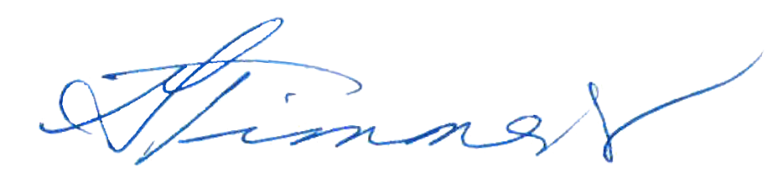
Gwilyn Timmers
Public Services Manager
Museum of Anthropology

